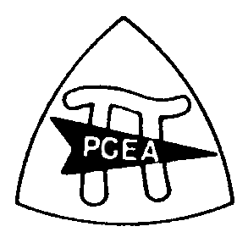
Penn Cambria Education Association
Scholarship Information Form and Application

The Penn Cambria Education Association (PCEA) will be awarding scholarships based upon the following criteria: essay, community service, extra-curricular activities, and admission to a post-secondary school. Preference is given to those pursuing a career in education and to PCEA households. Please fill out the information below as well as on the back of this paper. Attach the following to this information sheet:
- your typed essay
- copy of your acceptance letter to post-secondary school
- copy of your transcript

Return items to Ms. Fochler in the Guidance Department before the deadline of Friday, May 10, 2024

Name: ______________________________________ Application # ______
Address: ___________________________________________________________________
___________________________________________________________________
Phone number: ________________________________

Application # ______
Post-Secondary Information
College or School where accepted: ______________________________________________
Major and/or field planned to pursue: ___________________________________________
Activities and Honors
List any school-related extracurricular activities in which you have participated:
____________________________________________________________________________________________________________________________________________________________________________________________________________________________________________________________________________________________________________________________________________________________________________________________________________________________________________________________________________________
Community Service and/or Employment
____________________________________________________________________________________________________________________________________________________________________________________________________________________________________________________________________________________________________________________________________________________________________________________________________________________________________________________________________________________
Essay
Respond to the following essay topic using the following format: typed, double-spaced, and include a header with your name and application #. Please limit your response to 250-300 words.
TOPIC: Teacher Influence
Tell us about a teacher that had a positive impact on your life.

